Databricks Genie RAG Assistant

This project demonstrates an enterprise-grade GenAI assistant built using Databricks native services.
The solution supports:
- Text-to-SQL querying
- Retrieval-Augmented Generation (RAG)
- Semantic search using Vector Search
- Structured and unstructured analytics

The project also leverages advanced Genie capabilities such as benchmarking, accuracy evaluation, prompt engineering, and metadata enrichment for improved query understanding.

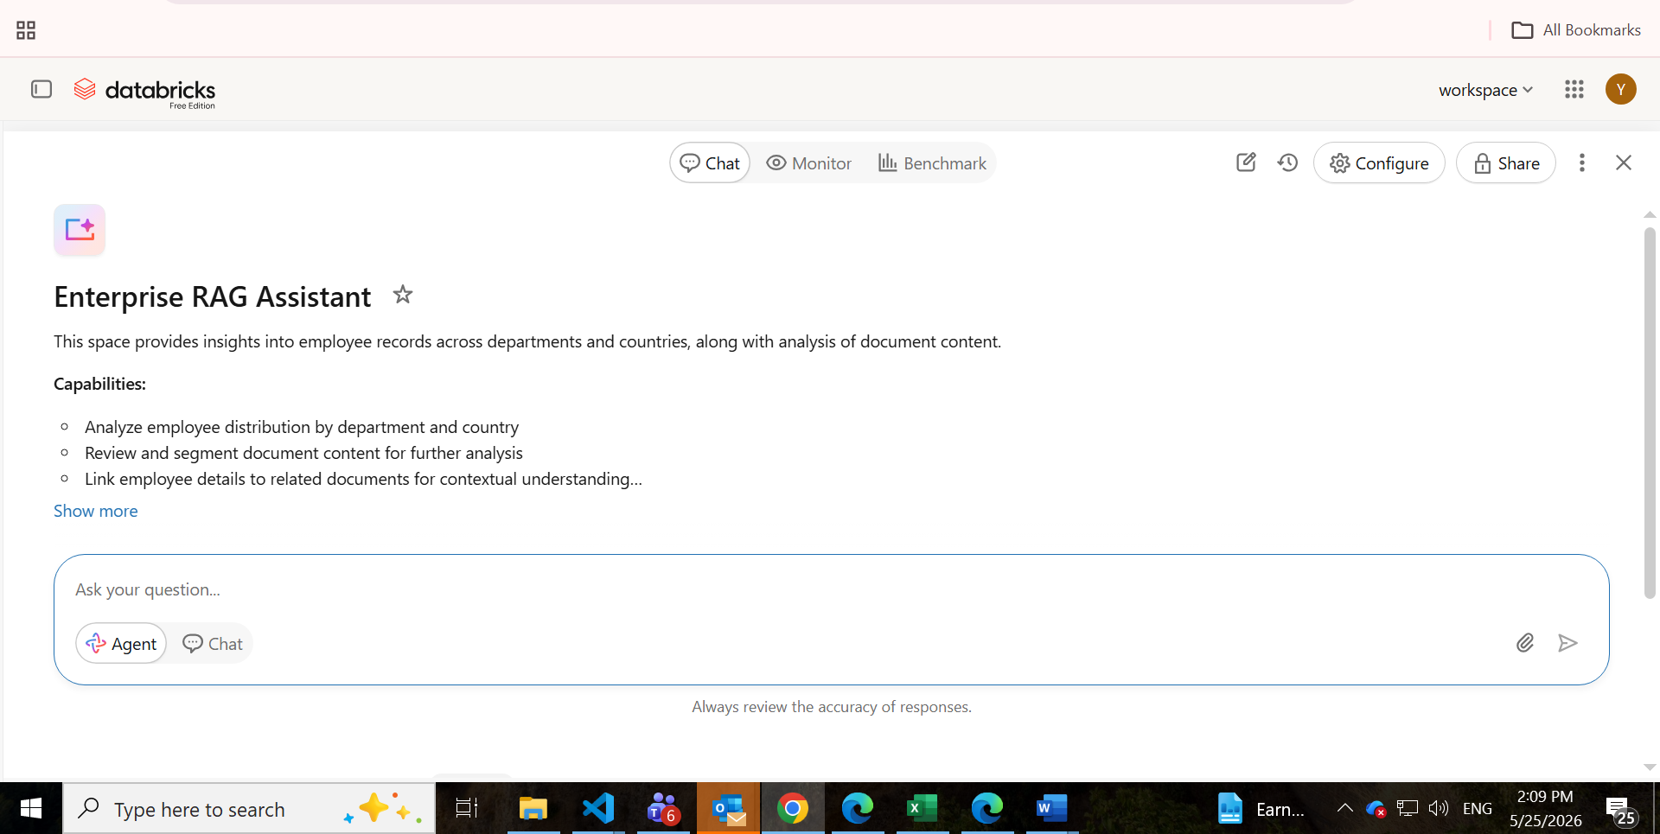

Structured and unstructured enterprise data was managed using Unity Catalog.

The implementation includes:
- Catalog creation
- Schema management
- Delta tables
- Volume creation for document storage

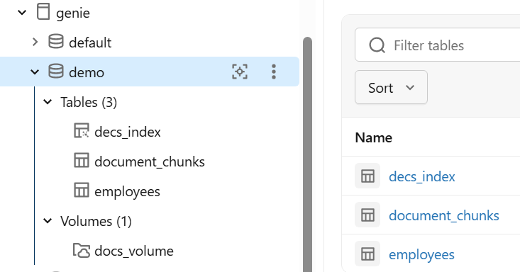
Genie Space Configuration:
Databricks Genie Space was configured for Natural Language querying, RAG workflow, metadata-aware querying, Prompt Engineering, schema understanding.
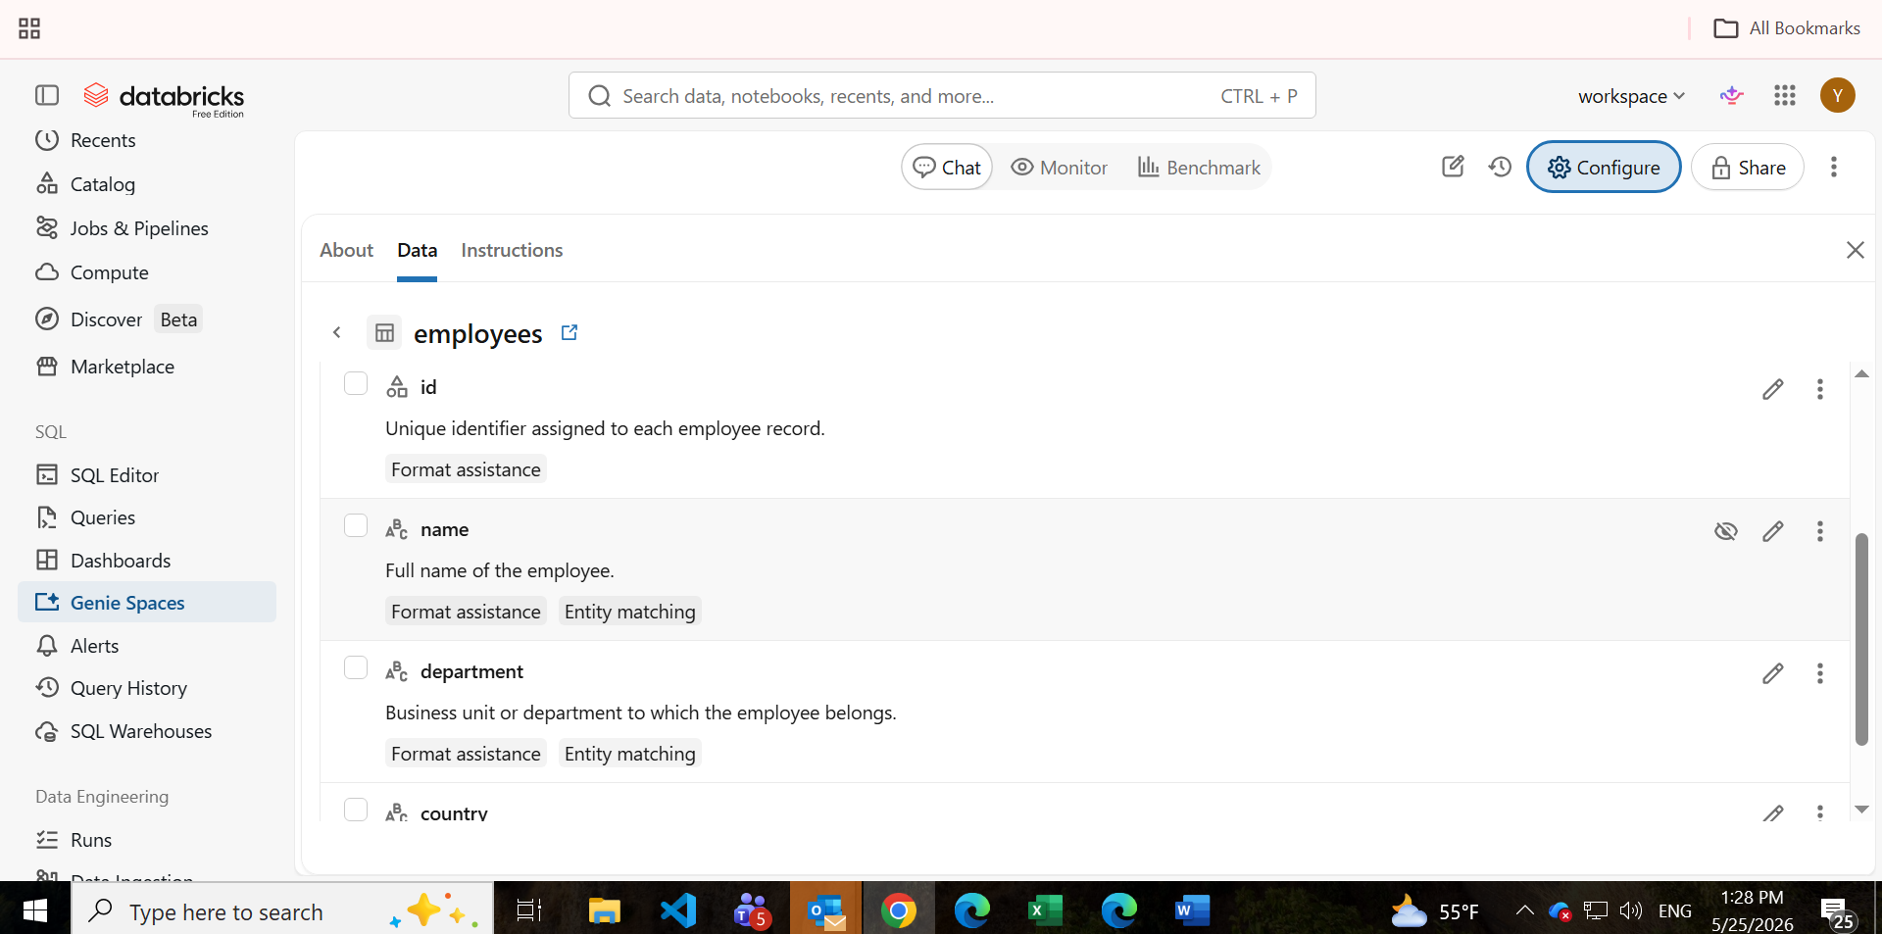

Query Example:
RAG Query-
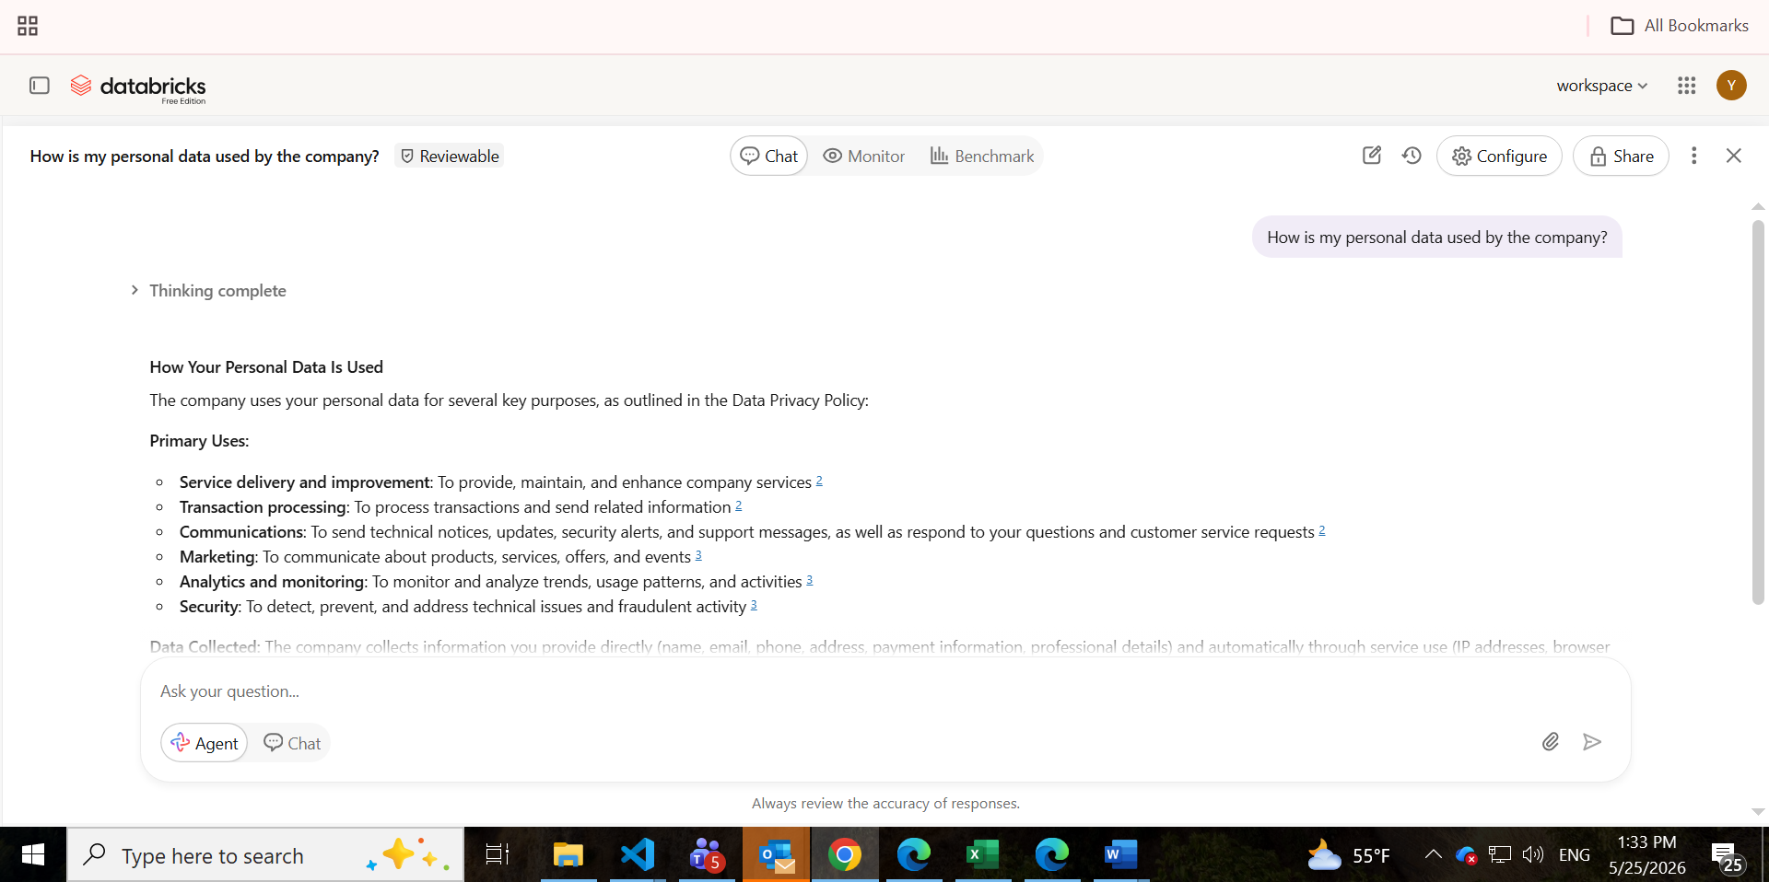

Text-to-SQL Query:
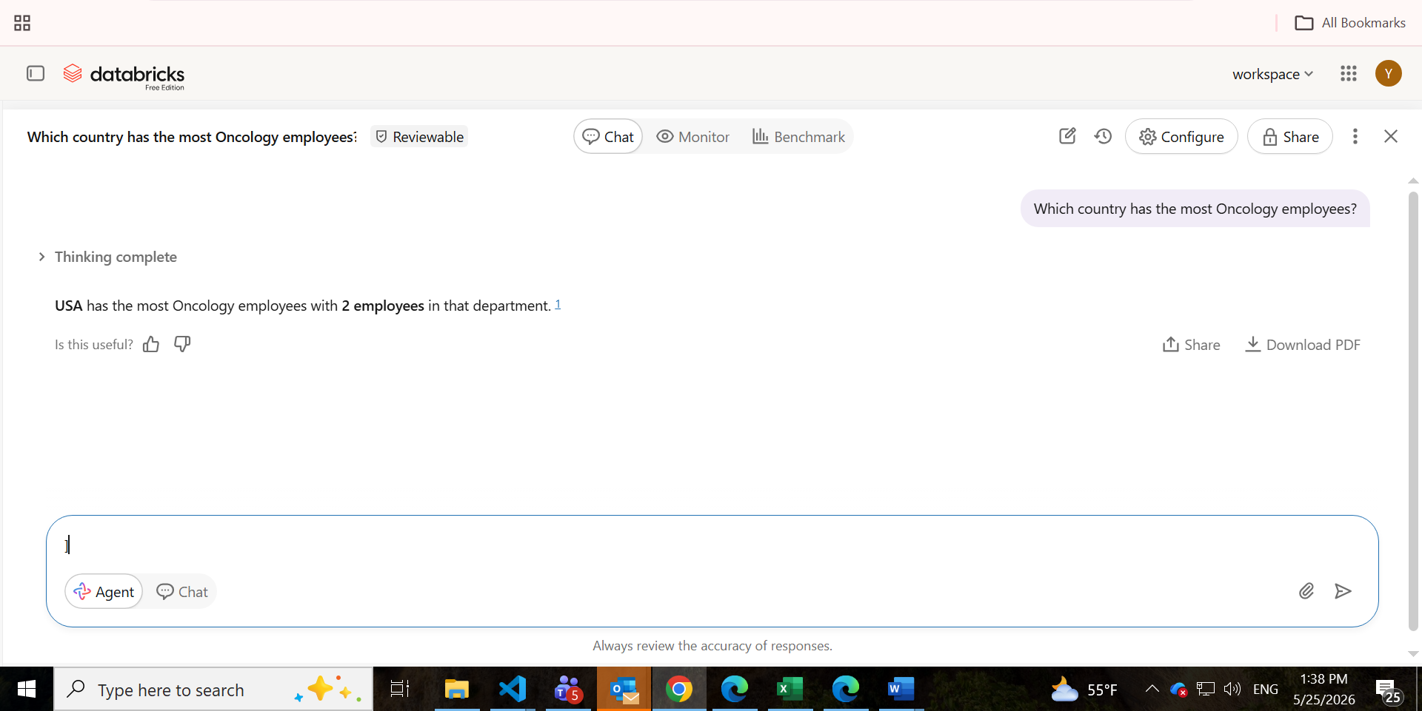
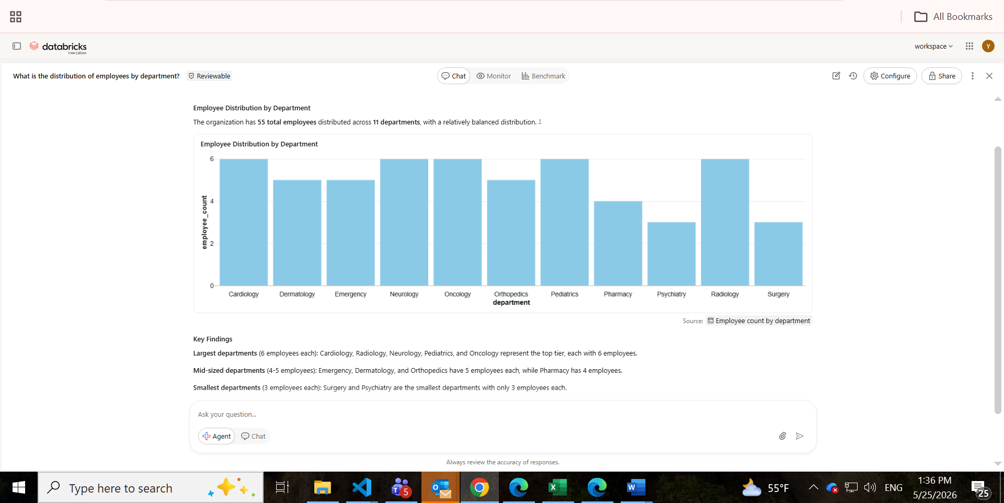

Benchmarking & Accuracy Evaluation:
Advanced Genie benchmarking capabilities were used to evaluate generated responses and improve query accuracy through prompt optimization and metadata enrichment.
